Living Well with MS Module 2

Understand and managing fatigue

Welcome to week two. We hope you found the first week useful and are starting to learn more about self-management and what it means for you.

This week we’ll consider fatigue. This module will help you to understand your fatigue better and identify things you can do to manage it - whether you are experiencing it now, or might do in the future.

In this module you will:

- develop your understanding of fatigue and how it affects you
- reflect on what you are doing which helps you to manage fatigue and identify new things to try
- share and hear ideas from others about how to live well and manage fatigue
- develop your personal goals and share experiences of working towards them

This module may take you up to 30 minutes to complete, depending on how you choose to use the exercises.

What is fatigue and what does it feel like?

Fatigue is a common symptom experienced by many people living with MS. You may already have an understanding of how fatigue affects you. Or you may be unsure whether what you are experiencing is fatigue or just ‘ordinary’ feelings of tiredness.

The fatigue associated with MS is different to ‘ordinary’ tiredness. It can manifest itself in different ways. Like many other symptoms it will be unique to you and your situation.

Some people describe it as:
- an overwhelming sense of tiredness with no obvious cause
- feeling extremely tired after very little activity
- waking up feeling as tired as you did when you went to sleep
- your limbs might feel heavy, and it might be harder to grasp things or to write
- having difficulties with balance, vision or concentration

Have a look at this video and hear people living with MS describe how fatigue is for them.
Have you experienced fatigue? If so, how would you describe
your fatigue?

- We may ask you to share this during the virtual chat

People attending our sessions often tell us that explaining their experience of fatigue to others can be tricky and can cause feelings of frustration. They find it difficult when people say things like:

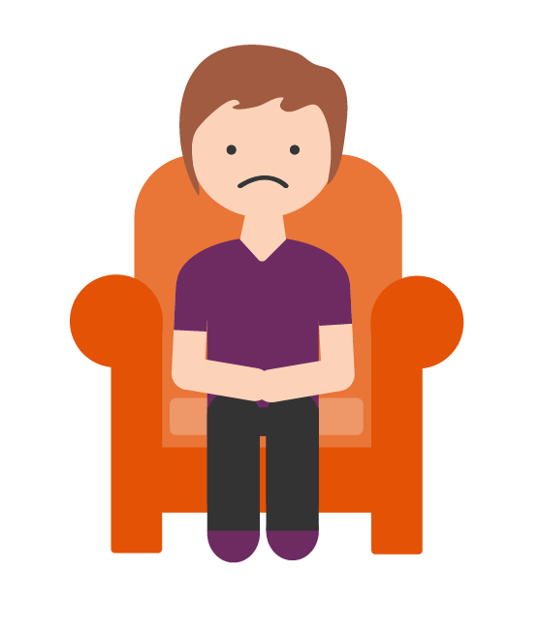
Well, you look fine…?

Oh I know…
I’m tired too

Maybe you just need an early night?

It can be a challenge to accurately describe how fatigue affects you and makes you feel. Maybe it’s something that you also struggle to understand?

What causes fatigue?

By understanding what’s causing it or why you are feeling fatigued you can help to learn how to manage it.

You may find it useful to read through this page from our website. It explains the various reasons why people living with MS may experience fatigue.

How to manage it and live well
There are many techniques and options to try out to help you to live well and manage your fatigue. You’ll have an opportunity to reflect on this further as you work thorough the following activities.

Your internal battery

Many people find the battery analogy helpful when thinking about energy and managing fatigue.
We all have an internal energy reserve or battery. Over time we learn about the activities we do that help re-charge our battery (such as rest, sleep and relaxation) and those that can deplete it (such as stress, taking on too much or general busy lives).

When self-managing fatigue it can be helpful to consider how we can conserve and use our energy more carefully. Working smarter, not harder.

Consider this:
- think about your fatigue or energy levels in terms of units, like batteries, spoons or cups – whatever works for you!
- ideally what you want to do is keep your energy level between green and yellow
- if it goes as low as red then there may be no other option but to stop and rest and it may take longer for you to recover
- if we avoid getting as low as red then we have a chance to recover more quickly
- you may choose to use small units of energy to be able to do more over a longer period
or
- you may choose to use lots of units on one important activity and accept that you’ll need to recharge your battery by resting afterwards

To learn how to self-manage fatigue effectively it’s important for us to identify how and where we use our energy.

Have a look at the table below. We’d like to invite you to use this over the course of one day. Jot down the activities you did in that day, the time of day you were doing them, and consider how much of your energy it took.

Activity | When did you do it  (E.g, time)? | High | Medium | Low
E.g, getting ready  for work | 7am |  | √

By identifying the areas where you’re more likely to feel fatigued, you’ll be able to start making a plan which can help you to manage it more effectively.

Once your table is complete, consider which tasks caused the biggest problems with fatigue.
Then consider the following questions: *
In terms of energy and fatigue…
What aspects of the task were the most challenging?

Did your experience of this task before diagnosis differ? Have you always found it challenging?

Do you generally find physical or mental tasks more challenging? Or both?

Did how you felt depend on other things? Such as who you did it with, when you did it and where you did it?

Did your emotions and feelings play a role? For example, stress, conflict or meeting others expectations?

- We’ll invite you to share your learning from this activity
during the virtual chat.
*If you didn’t have any difficulties with fatigue on the day you filled the chart it may be helpful to think of a time when fatigue or energy were an issue for you.

Hopefully by thinking about how you keep your battery topped up you’ve been able to identify things you can do that can help to reserve energy.

It can also help identify which strategies to use when your battery is completely flat.
Wellness tool box
What are you doing that helps?
You may wish to add to this following our virtual chat.

- We’ll discuss this further during the virtual chat and will invite you to share what’s in your toolbox.

It can be helpful to share what works for us, as it may help someone else or give you some inspiration for things to try.

Here’s a video of Kirsty explaining some techniques that work for her.
This video may give you some ideas about how exercise can help you to manage fatigue.
- During or after our virtual chat you may find it useful to complete this chart.

Activity or task | Level of fatigue | How could you do this differently?  Is there another approach you could use?

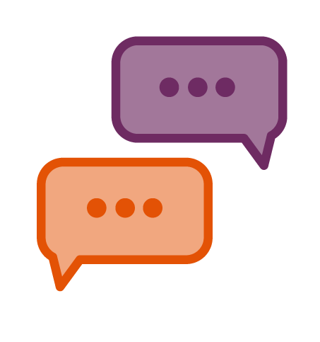
This week’s virtual chat will cover:

- quick relaxed warm up
- goal check-in. How did we all get on? We’ll look at setting a new goal or keeping going with the one you are working on
- what we learned about our own fatigue
- strategies to use to manage fatigue

Warm up

We’ll ask you to share the following:

- remind everyone of your name
- one thing you like about where you live and why
we should visit it (think like a tourist board!)

We look forward to seeing you then!

