Living Well with MS Module 3

Life Balance

Welcome back!

In this module we’ll think about the activities and tasks we do in day to day life. What works for us, what is tricky and what could we change or add? This is an opportunity to stop and think about what we’re doing and how satisfied we are with it.

In this module you will:

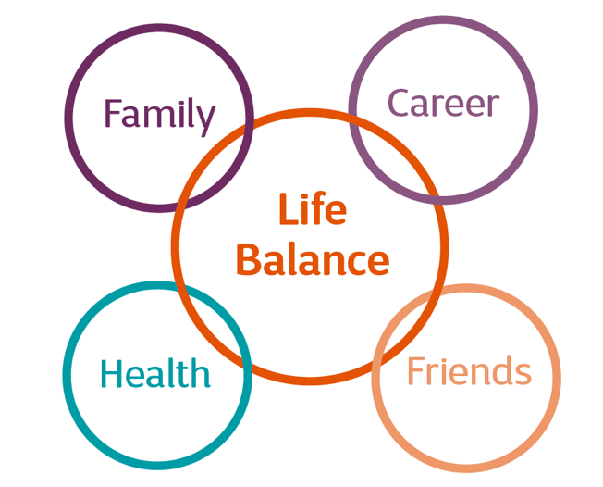
- have time to think about what tasks and activities you do in day to day life

- reflect on what’s working for you and how satisfied you are with what you’re doing

- share and hear ideas from others about how they manage tasks and work towards life balance

- review your personal goals and share experiences of working toward them

This module should take you around 20 to 30 minutes to work through and complete.

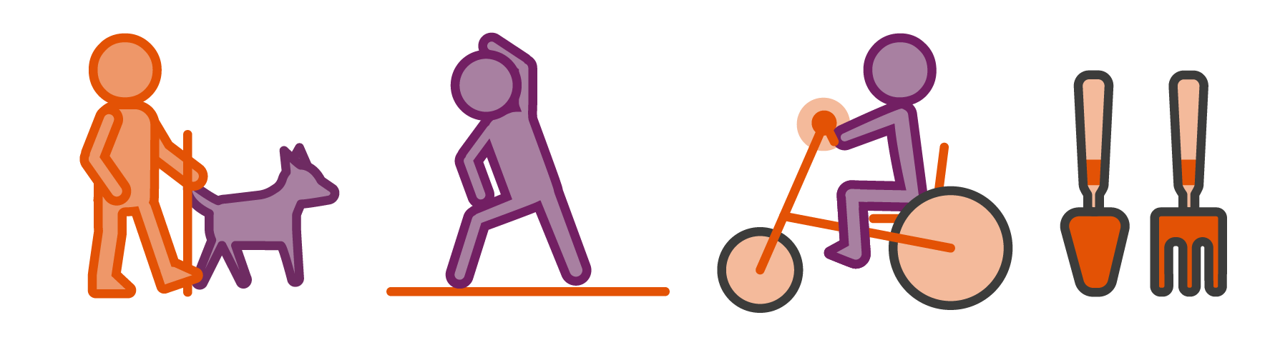

Humans are inherently active beings. It’s in our make up to occupy ourselves.

The activities and tasks we chose to occupy ourselves are personal to us.

They help to:

- form our identity
- connect us with others
- give us a sense of achievement, enjoyment and satisfaction
- provide an income
- keep us active and healthy
And so much more.

The activities we choose to engage in will change over time with the changes that occur as we move through life. These might be as a result of having children, moving to another area, retiring or adjusting to living with a health condition.

When a change occurs we often need to reassess what we do, how we do it and whether we feel satisfied with doing it.

Watch this video of Susi explaining what she thinks about life balance

We’d like you to spend some time reflecting on how life is for you at the moment.

In the following exercise we’ll look at life balance. We invite you to consider these three areas:

Taking care
of yourself
(Things you do that help you look after yourself).

The fun stuff
(Things you enjoy, leisure interests - on your own or with others).

Feeling productive
(Things you do that you feel is work or productive).

Please jot down in each column below the
activities you do in each of these three areas.
E.g, work, house work, study, child care etc.

E.g, going to the cinema, eating out, a pint down the pub, bingo etc.

E.g, good sleep routine, meditation, exercise etc.

Have a look at the activities and how they are balanced on the scale. Then reflect on the following questions:

- Is there a good balance of activities?
- Are you doing more in one column than in others?
- How satisfied are you with what you’re doing?
- How satisfied are you with how you’re doing things?

Use the shapes below to capture your reflections
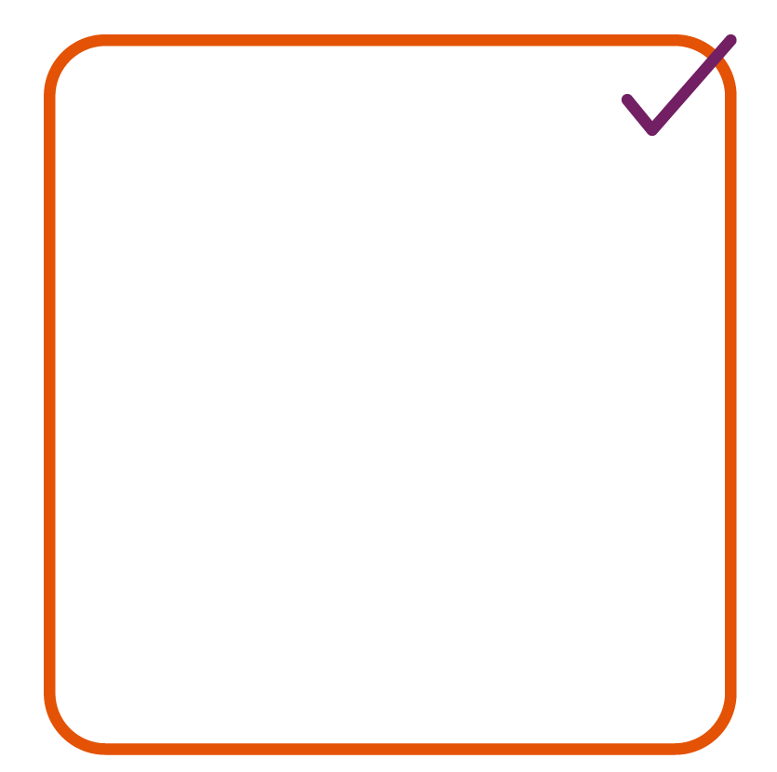

Bin

Keep

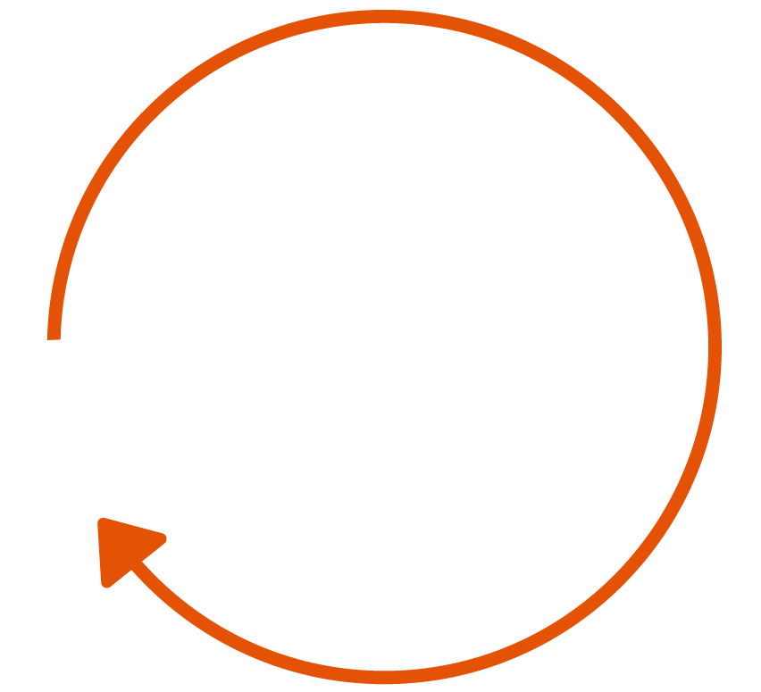
Add

Change or adapt

- We’ll invite you to share your learning
from this exercise during the virtual chat.

Now you’ve completed this exercise, have a listen to what other people think about life balance and what it means to them.

Watch this video of Craig talking about life balance.
And here’s a video from Annette talking about her experiences.

You may wish to jot down your reflections on this exercise here.

Perhaps you’ve identified things that you want to add to change? You could use this space to make a list or plan of how you’ll work towards achieving this.

Checking in on our goals

Before our virtual chat, briefly consider these questions about the goals you set yourself last week.

How did you get on?

What went well?

What would you do differently next time?

Are you continuing with this goal or making a new goal?

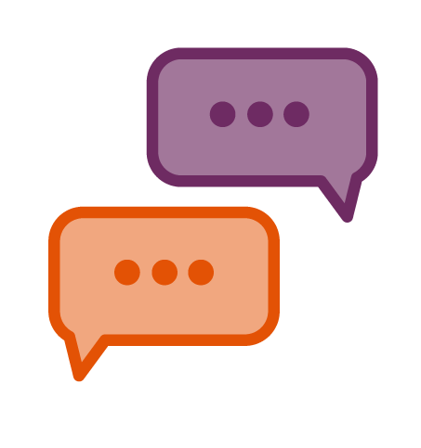
This week’s virtual chat will cover:

- quick relaxed warm up
- reflections on the life balance exercise -
in pairs then in the whole group
- goal check-in

Warm up

We’ll ask you to share the following:

- tell us something you do for leisure or fun, or
something you’d like to do but have never tried

We look forward to seeing you then!

