Living Well with MS Module 1
What is self-management?
What does it mean and how do you do it?

In this module you will:
- develop your understanding of self-management and how it applies to you
- reflect on what you are doing which helps you to live well and identify new things to try
- share and hear ideas from others about how to live well
- learn about and start to set personal goals

This module will take you no longer than 30 minutes to complete.

Getting a diagnosis of MS can be confusing and overwhelming. You may feel that you haven’t got your head around what it means for you yet. MS affects people differently and no two people will have exactly the same experience.

Watch our videos to hear Steph and Rachael talk about how they felt when they were first diagnosed.

As you work through the materials on your own and when you meet others during the virtual chats, you’ll get the opportunity to think about what’s important for you. You’ll reflect on what you currently do to self-manage and also get ideas from others about things you could try which may benefit you. Equally, the information you share on the virtual chat may be of great support and assistance to others.

It can be really useful to connect with others in the same situation. By sharing experiences, thoughts and feelings we can get a sense of peer support, validation and reassurance.

Watch Steph and Rachael talk about their experience of connecting with others on the Living Well with MS session.

Wellness and wellbeing
So, what is living well?

When thinking of wellbeing or wellness it may be helpful to think about yourself as a whole person. What are all the parts that make you the unique person that you are?

Consider this diagram and what’s important to you in all of these areas.
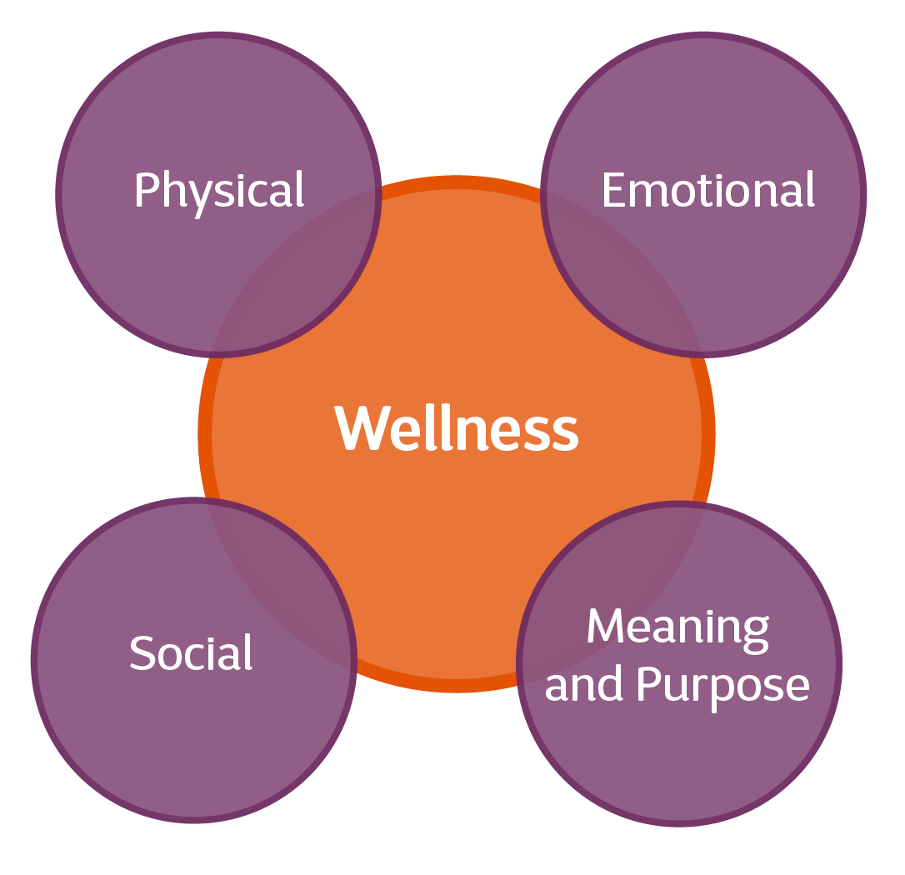

Physical
Your body and looking after it. You may think of things like nutrition, exercise and activity and healthy habits.

Emotional
Your thoughts and feelings. Being in touch with and expressing your emotions - taking care of your emotional health.

Meaning and purpose
Finding meaning and purpose, forming beliefs, values and ethics. Feeling connected with yourself and others.

Social
Relationships, community, connections. How we relate to others, where we do it and who we are connecting with.

Being ‘well’ and ‘living well’ means so much more than just the absence of symptoms or being free from illness. It’s about noticing what’s going on in all of these areas and attending to them, making sure everything is working for us.

Everyone will have different benchmarks, expectations and desires around wellness. This can only be judged by you. You’re the expert on yourself.

What does wellness or wellbeing mean to you?

Note your thoughts, ideas and reflections

Your wellness toolbox

There will be many things that you already do that help you to live well. Some of these may be unique to you and some you will share with others.

One of the exercises we’ll ask you to join in with during the virtual chat is ‘the road exercise’. To prepare for this it would be useful for you to think about developing your own toolbox of things that help you to live and stay well.

To develop your toolbox we’d like to invite you to consider the following questions:

- What are you currently doing that helps you
to feel well?

- What helps make your life feel fulfilled?

In answering these questions you might think about people, activities, interests, pets, and connections in your life. It can be anything that you feel helps you feel good, keeps you interested, helps you stay on track or gives you purpose or meaning. There are no right or wrong answers.

Once you’ve thought about all the possibilities, you can add them to your wellness toolbox below. You can add as many as you like, please don’t be limited by this box!

- During the virtual chat we’ll invite you to share and discuss some of the different things we have identified.

Pop your ideas down here……

- Add your final thoughts to your
toolbox, for sharing during the
virtual chat for the ‘road exercise’.

What is self-management?

What does the term self-management actually mean and how do you do it?

You can read about it in this helpful blog written by Kirsty, one of our volunteers, who shares her experience of self-management.

And you can watch our video of Susi talking about what she feels self-management is.

How would you define or describe self-management and how it relates to you? Use the space below to jot down your ideas. You’ll learn more about this at the virtual session and may want to use this space for your reflections.

Getting the most out of health care appointments

Everyone, at some point in their lives, will attend a healthcare appointment. Many people have told us that in the early stages of an MS diagnosis those initial health care appointments can feel confusing, daunting and stressful. They may also be brief and infrequent. So it’s important to make the most of that time and make sure it benefits you.

Did you know that people living with a long term condition spend up to three hours each year with healthcare professionals? Obviously this depends on the person and the situation, but it does highlight how much time is spent managing things yourself and using your own resources.
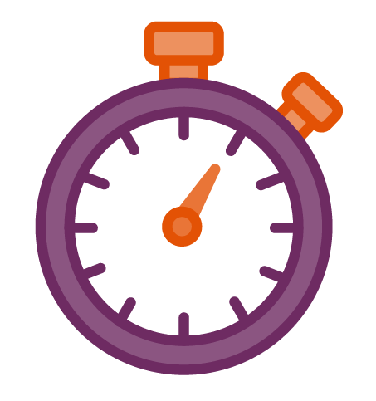
Given that appointments can often be brief or infrequent it’s important that they are used to your full advantage!

Remember, the appointment is about you, for you. This is the time to ask questions or talk about what is important for you and your life.

Are you getting what you need from your healthcare appointments?

What is helpful about the time you have with healthcare professionals?

Is there anything you could do that you think would enhance your health care appointments?

- We may discuss this during the virtual chat
People who’ve attended our Living Well sessions have shared lots of useful tips and advice on how to manage health care appointments. Here’s a summary of some of the top tips shared.

Plan ahead | Do you keep a diary or planner to note patterns of symptoms or challenges? This may be something you want to try. It can help keep you on track, remind you of what’s important and help the healthcare professional understand what’s important to you.
Make a list | Make a list and use it! It may be helpful to tell your healthcare professional that you have a list to work through. Perhaps you could give them a copy.  If it’s a big list then you might want to request a longer appointment, or two appointments, if you can.
Prioritise | Using a list? Then make sure you prioritise what’s on it and what’s most important for you to cover.  Sometimes it can seem easier to keep the more tricky or awkward things to the end. If something is important to you then pop it at the top of your list instead.
‘Teachback’ | Repeating back what you’ve been told can make sure that both you and your healthcare professional are clear on what the instructions or advice is, and whether you have fully understood each other.
Extra set of ears | Can you take someone with you? They could help take notes, remind you of things or give their view (with your permission) about how things are from their perspective.  Perhaps you would be allowed to record the meeting? This could help you remember details or instructions.
Ask for information to be given in a format useful for you. | Do you like to use digital platforms? Is there an app or website that could help you?  Is there something useful on Youtube or similar you could be referred to?  Do you need or prefer written information?
Questions? | Don’t be afraid to ask.  It’s natural to have questions. Try and ask them at the time or write them down in advance.  This is your time. It’s about you and it’s important you get the most out of the time.
Got some of your own tips or ideas to share? Pop them down here!

You might want to try these questions……

Could you tell me what options I have for managing this issue/problem/symptom?

What are the pros and cons of these options?

Can you help me chose the right one for me?

Have a look at this page on our website for more helpful tips and advice on how to best use your appointment.

Goal setting

Setting and working towards goals can be a useful self-management technique.

Goals can help us to have meaning and purpose.

The ability to identify something that we need or want to do can help us to focus on, and work towards, the future.

Read more from Rachael about how her experience of goal setting has helped her.

You may not realise it but you’ll already be setting and working toward goals. For example, you may be thinking about and planning a holiday. Or you may be looking to make a career or life change. These may not be things you put down on paper, they could just be thoughts you are having. But they’re still goals.

This could be achieved fairly quickly so could be considered a short term goal.

Completing a chore that you’ve been putting off or avoiding. For example, paying a bill or making a phone call.

This may take longer and have more steps and things to co-ordinate so could be considered a medium term goal.

Planning and organising a night out with friends or a family holiday.

This may take longer and have multiple steps and other factors to coordinate and manage so could be considered a long term goal.

Planning to move house or change your job.

We’d like to invite you to use the time on these sessions to think about something you want or need to do. Set it as a goal and work towards it over the next few weeks. It may be a long term goal that you work on over time, or smaller goals you can achieve on a weekly basis.

Choose something that is important and relevant to you.

To help prepare you for this you may want to consider
the following:

Is there something I want or need to do? Perhaps it’s something you’ve been avoiding or haven’t had the time to focus on.

What steps can I take to work towards achieving this goal?

Do I need to have a deadline?

Do I need help to achieve this? If so, who could I ask?

- At the end of the virtual chat we’ll invite you to share what your goal is for the coming week. Don’t worry, there’s no pressure to share if you’d rather keep it to yourself.

This week’s virtual chat will cover:

- quick relaxed warm up
- road to wellbeing exercise
- what does self-management actually mean?
- goal setting

Warm up

We’ll ask you to share the following:

- your name
- where you’re from
- what made you want to attend this session

We look forward to seeing you then!

